

Department of Mathematics and Natural Sciences
Physics -112 Lab Assignment: 02

Resources:
Link for online lab:
https://phet.colorado.edu/sims/html/charges-and-fields/latest/charges-and-fields_all.html
List and link for the graph-plotting softwares:
● Desmos (Online): Desmos | Let's learn together.
● Graph (Offline): Download | Graph (padowan.dk)

Tutorials:
● Tutorial link for plotting in Desmos :
https://www.youtube.com/watch?v=-lIUNWVKnUY
● Tutorials link for the Graph :
How to install graph software:
https://youtu.be/e19JqLJMx3A
How to draw a curve using graph software:
https://youtu.be/QBkdzU_8vVo
How to calculate the slope of a line using graph software:
https://youtu.be/z4cMiUFu5j8

Objective:

In these activities you will use the Simulation: Charges and Fields to develop your understanding of the relationship between electric fields and electric potential.

Theoretical Background:
The Electric field is a vector quantity that exists at every point in space. The electric field at a location indicates the force that would act on a unit positive test charge if placed at that location.
The electric field is related to the electric force that acts on an arbitrary charge
‍by,
‍ $E=F/q$

The dimension of the electric field is newtons/coulomb.
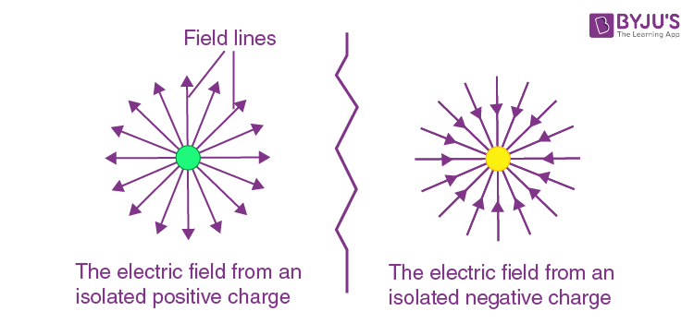
Electric potential energy is the energy that is needed to move a charge against an electric field. You need more energy to move a charge further in the electric field, but also more energy to move it through a stronger electric field.
Mathematically we can say that,
E = W/Q
The dimension of the electric potential is joules/coulomb.

Activity 1:
Go to the following link : https://phet.colorado.edu/sims/html/charges-and-fields/latest/charges-and-fields_all.html

- From the box at the bottom of the screen, drag a red +1 nC charge into the middle of the screen.

- If not already selected: Select ‘Electric Field’. How does the brightness of the arrow relate to the strength of the field? What happens when you check/uncheck ‘Direction only’? Which way do the arrows point for a positive charge?

- The brightness of the arrows likely relates to the strength of the field - brighter arrows indicate a stronger field.
- When "Direction only" is checked, it shows only the direction without indicating strength.
- For a positive charge, the arrows should point outward from the charge.

- Drag the red +1 nC charge back into the box at the bottom, and then drag a blue –1 nC charge onto the screen. Which way do the electric field arrows point for a negative charge?
- For a negative charge, the electric field arrows should point inward towards the charge.

- Click on the yellow Sensor at the bottom and drag it across the electric field. What information do the Sensors show?
- The Sensor shows information about the electric field strength and direction at different points.

- What happens to the electric field as you move further from the charges?
- The electric field strength typically decreases.

- Take the Voltage meter (labeled ‘0.0 V’). What information does the voltmeter give? What information is given when you click on the pencil (you should have a green circle)? What does the green circle represent? (If you’re not sure, move on and come back to this later.)
- The Voltage meter (labeled ‘0.0 V’) gives the electric potential at a point.
- Clicking on the pencil allows to set a reference point (green circle) for voltage measurement.
- The green circle represents the point where the voltage is being measured in the simulation.

Activity 2:

- Stack six +1 nC charges on top of each other somewhere on the left side of the screen. (It can go anywhere, but there needs to be enough space to measure 8 m away.)
- From the box at the bottom, drag a Sensor and place it 1 m to the right of your charge. This sensor measures the E field at the location of its placing. In the table, record the E field magnitude at a distance r of 1 m. Ignore the degrees. (Check / Uncheck Values as need be)
- Drag the Sensor to the other distances shown in the table, then record the E field measurements.
Distance, r (m) | Electric Field, E (V/m)
1 | 53.1
2 | 13.3
3 | 6
4 | 3.37
5 | 2.15
6 | 1.50
7 | 1.10
8 | 0.84

- Drag your Sensor back and replace it in the box at the bottom of the screen.
- Using the voltmeter, record the potential V by drawing a green circle on the screen at each distance. Fill in the table on the next page. Include a screenshot with all of the green circles at the end of this document.

Distance, r (m) | Voltage, V (V)
1 | 53.9
2 | 26.9
3 | 18
4 | 13.5
5 | 10.8
6 | 9
7 | 7.7
8 | 6.7

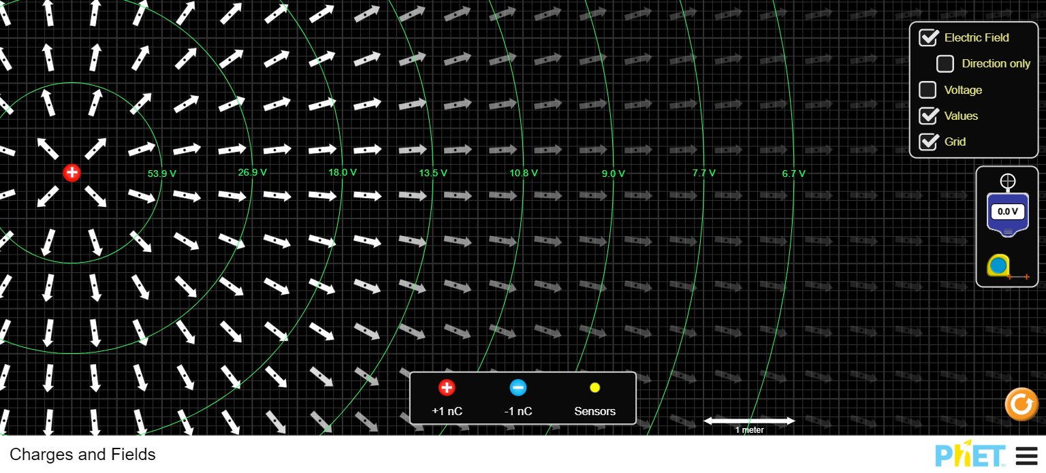

- Write the equation for the electric field at any distance r from a point charge q:
$$E=\frac{kq}{r^{2}}$$

- Write the equation for the potential at any distance r from a point charge q:
$$V=\frac{kq}{r}$$

- Using the previous table(s), make a graph of electric field E and distance r to determine Coulomb’s constant k using the appropriate trendline.
(Hint: there are 2 ways to do this. Either make a graph and then create the appropriate trendline, or figure out how to make the graph into a straight line and then use a linear trendline. Once you have a trendline, compare the equation written above to the equation of the trendline to find k)

- The electric field E due to a point charge is given by Coulomb's law:
$$E=kQ\left(\frac{1}{r^{2}}\right)$$
To make the graph linear, we can plot $(E vs\left(\frac{1}{r^{2}}\right))$ because:
$$E α \left(1/{r^{2}}\right)$$
So, if we plot $E$ on the y-axis and $\left(1/{r^{2}}\right)$ on the x-axis, we should get a straight line with a slope equal to $kQ$.

Distance, r (m) | $1/{r^{2}}$ ($m^{-2})$ | Electric Field, E (V/m)
1 | 1 | 53.1
2 | 1/4 | 13.3
3 | 1/9 | 6
4 | 1/16 | 3.37
5 | 1/25 | 2.15
6 | 1/36 | 1.50
7 | 1/49 | 1.10
8 | 1/64 | 0.84

From the graph we can find 2 points,
$x_{1}=0.31$, $y_{1}= 16.84$,
$x_{2}= 0.46$, $y_{2}= 25.34$
Slope, m = $\frac{y_{2}-y_{1}}{x_{2}-x_{1}}$ =$\frac{25.34-16.84}{0.46-0.31}$= 54.13
From the equation, we can identify the slope $kQ$ as approximately 54.13
$$kQ=m$$
$$=>k=\frac{m}{Q}$$
$$=>k=\frac{54.134}{6 ×{10}^{9}}$$
$$=>k=9.02×{10}^{9}Nm^{2}/C^{2}$$
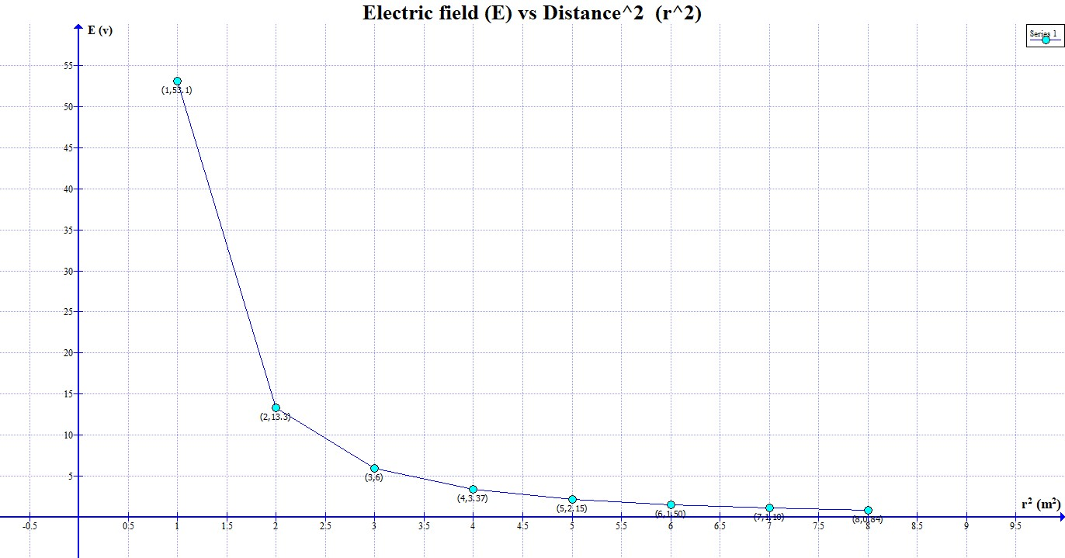

- Insert the graph below and write down the k value that you found. Compare this value to the known value found on the equation sheet or in class slides using percent error or percent difference (whichever is most appropriate)?
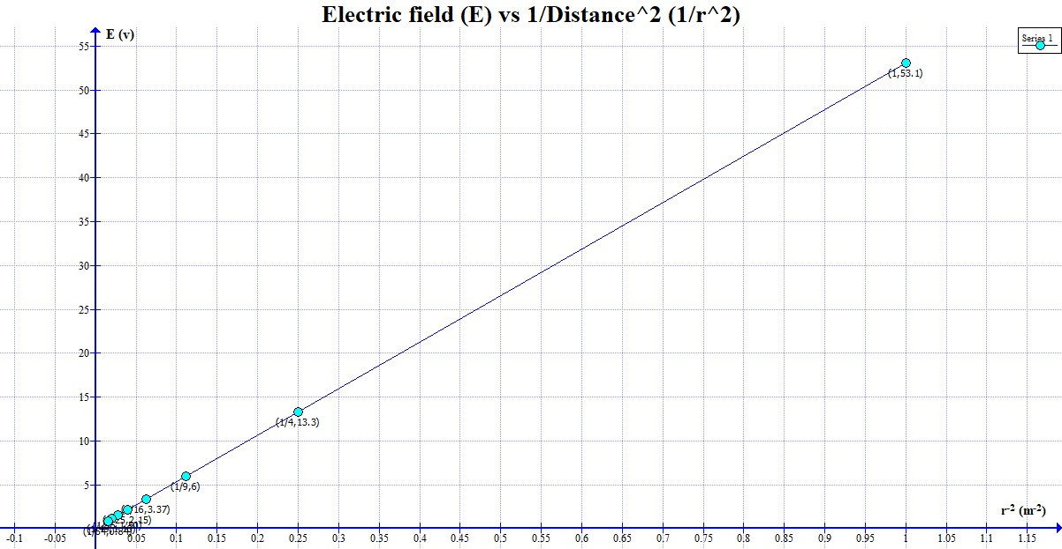

$$Percent Error=\frac{\left|Experimental Value-Theoretical Value\right|}{Theoretical Value}×100\%$$
$$=\frac{\left|9.02×{10}^{9}-9×{10}^{9}\right|}{9×{10}^{9}}×100\%$$
$=$0.25%

- Using the previous table(s), make a graph of voltage V and distance r to determine the constant k again using the appropriate trendline.
(The same hint as above applies, but the work will be slightly different because the equation is different.)

Distance, r (m) | $1/r$ ($m)$ | Voltage, V (V)
1 | 1 | 53.9
2 | 1/2 | 26.9
3 | 1/3 | 18
4 | 1/4 | 13.5
5 | 1/5 | 10.8
6 | 1/6 | 9
7 | 1/7 | 7.7
8 | 1/8 | 6.7

We know that,
$$V=\frac{kQ}{r}$$
Here, to make the graph linear, we can plot $(V vs\left(\frac{1}{r}\right))$ because:
$$V α \left(1/r\right)$$
From the graph we can find 2 points,
$x_{1}=0.39$, $y_{1}= 21.27$,
$x_{2}= 0.48$, $y_{2}= 26.04$

Slope, m = $\frac{y_{2}-y_{1}}{x_{2}-x_{1}}$ =$\frac{26.04-21.27}{0.48-0.39}$= 53.9

From the linear regression, we found the slope of the line to be approximately 53.9. This slope corresponds to $kQ$ in the equation, $V=\frac{kQ}{r}$
$$kQ=m$$
$$=>k=\frac{m}{Q}$$
$$=>k=\frac{53.9}{6 ×{10}^{-9}}$$
$$=>k=8.98×{10}^{9}Nm^{2}/C^{2}$$

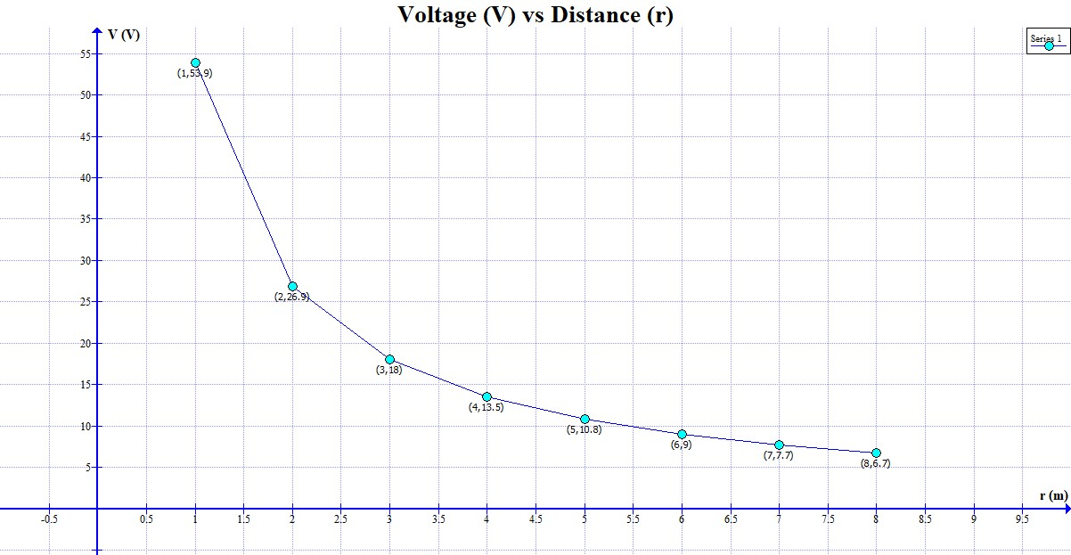

- Insert the graph below and write down the k value that you found. Compare this value to the known value using percent error/difference?

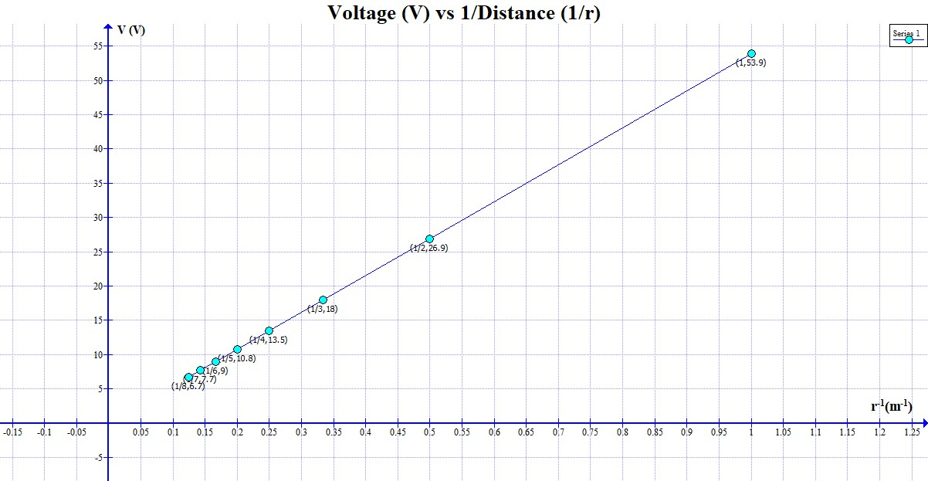

$$Percent Error=\frac{\left|Experimental Value-Theoretical Value\right|}{Theoretical Value}×100\%$$
$$=\frac{\left|9×{10}^{9}-8.98×{10}^{9}\right|}{9×{10}^{9}}×100\%$$
$=$ 0.19%

